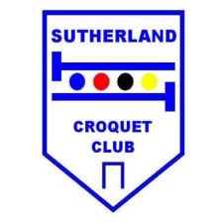
Sutherland Croquet Club Inc
1 Rawson Avenue, Sutherland

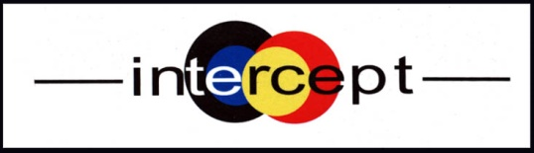

Golf Croquet Tournament
Handicap Singles & Doubles
Saturday 5 October – Monday 7 October 2024
Open to any player affiliated to Croquet NSW

SINGLES: 3 ranked blocks of 8 players – Advantage Handicap Play
DOUBLES: 2 blocks Hi-Lo allocated pairs – Advantage Handicap Play

Enquiries: Margaret Lund
Email: mjlund60@gmail.com
Phone: 0466 807 280

Tournament Manager: Andrew Kelly - 0414 313 600

****CLOSING DATE FOR ENTRIES****
15 September 2024

24 players  Everyone plays 7 Singles and 5 Doubles games  (Partners will be allocated by the  Tournament Manager)  Initially, there will be a limit of 6 players  from any one club. | $50 per person  Morning and afternoon teas available daily  Saturday and Sunday  We can arrange lunch boxes to order - or BYO  Monday  Be our guest for Lunch !
DON’T DELAY – BOOK TODAY!
Registration and Practice Friday 4 October from 1:30pm

All players should arrive by 8am on day 1 (for information session)
Play to commence 8:30am each day

Entry Form:
Complete an application form (below) and email to

Margaret Lund - mjlund60@gmail.com
Phone: 0466 807 280

Entry fee of $50.00 payable to:
Sutherland Croquet Club
BSB 062 259 Acct No. 00906900

Please include your surname and "Intercept" with your payment.

Sutherland Croquet Club
Saturday 5 October – Monday 7 October 2024

****CLOSING DATE FOR ENTRIES****
15 September 2024

Name
Address
Mobile |  |  | Home:
E-mail address
Club
Handicap |  | Index |  | ACA ID
Are you willing to assist with refereeing? |  |  | Yes |  | No

