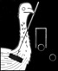
MAKARA 2015

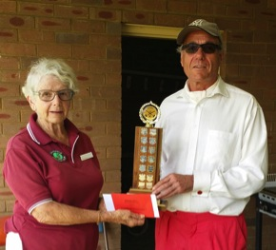
Following the tradition first established just over 30 years ago, MAKARA 2015 delivered two weeks of fiercely competitive - but very friendly - croquet. Detailed results of all the events can be found on CroquetScores.com.
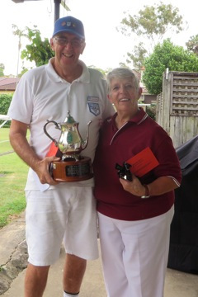
The Bronze and Silver Singles events were hosted by Strathfield Club.
Winner of the Bronze Singles (and the Wilson Trophy) was David Woods (Sutherland) with Susan Howland (Strathfield) (left photo) as runner-up.
The right photo shows Heather Smallbone presenting the Reid Trophy to Charles Britton(Marrickville), who was winner of the Silver Singles with David Surridge (Cammeray) as runner-up.
The Gold/Platinum Singles were hosted by Coogee Club. The winner of this event (and the Makara Trophy) was Rob Elliott (Coogee).

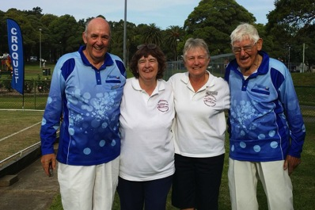
The Bronze/Silver and Gold/Platinum Handicap Doubles events were hosted by Marrickville Club.
Bronze/Silver Doubles winners were Ros Johnstone & Ann Shaddick (Sutherland / Strathfield)
with Wal Fernance & David Woods (Sutherland) as runners-up.
Gold/Platinum Doubles winners were John Eddes and Gareth Denyer (Sutherland).
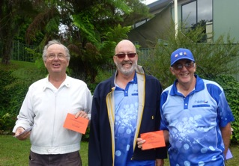

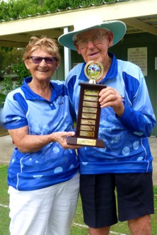
All the GC singles events were hosted by Port Hacking Club.
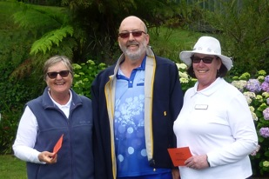
Winner of Division 1 was David Woods (Sutherland) with John Eddes (Sutherland) as runner-up. (Top R photo)
Division 2 was won by Lynda Toms (Port Hacking) with Lorraine Hatfield (Port Hacking) as runner-up. (Bottom R photo)
Winner of Division 3 (and the Fernance Trophy) was Dianne Bonnitcha (Sutherland) with Wal Fernance (Sutherland) as runner-up. (Photo on left)

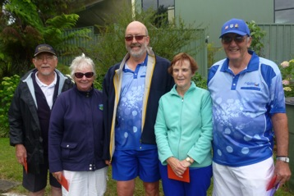
The GC Handicap Doubles event was hosted by Sutherland Club.

Prizes were presented by CNSW Board Chair Tony McArthur to winners and runners-up from each block as follows:
Block M - Frances Schembri & David Woods (Sutherland) were winners;
Lenora Everton & Bill Muller (Wollongong) were runners-up

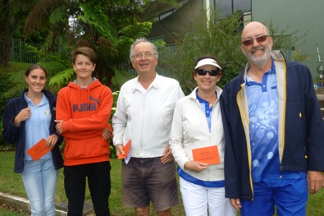
Block K - Deb Morgan & John Eddes (Sutherland) were winners;
Lana Sexton & Charlie Sharpe (Manly/Killara) were runners-up

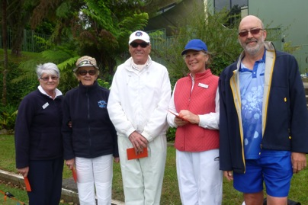

Block R - Roberta Flint & Charles Britton (Marrickville) were winners;
Val Robinson & Anne Cullen (Port Hacking) were runners-up.

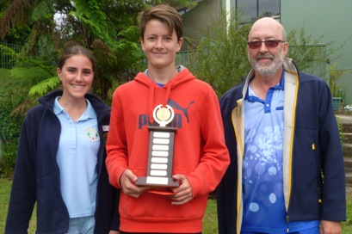

The round-robin (with over half the games played in some very heavy, wet conditions) was followed by a nail-biting finals series played in partly sunny conditions (!!) with the eventual winners of the Taylor Trophy being Lana Sexton and Charlie Sharpe.

Finally, a very big thank-you to the event managers, players, referees, and support teams from the various clubs! Without you all, MAKARA could not happen.

Lorraine Hatfield
Secretary, MAKARA Committee 2015.

