INTRODUCTION OF THE NEW GOLF CROQUET HANDICAP SYSTEM
INFORMATION BULLETIN No1

CNSW would like to provide the following information to its Members:

- The new Golf Croquet Handicap System is to be introduced nationally on the 3rd April 2017 and information is available from the ACA on https://croquet-australia.com.au/disciplines/golf-croquet/resources
- The New System is simple and straightforward. It has a greater range (23 levels ranging from -6 to 20) compared to the current system (13 levels ranging from 0 to 12). In the new system below 12, there are only even numbered levels, which is the same as the handicap numbering system for AC.
- The great majority of players who have handicaps between 11 & 3 will find that their handicap will not change. There may be some change for players with a handicap of 1 & 0
- As the vast majority of handicaps will not change, the banding for CNSW Divisions will not change ie Division 1 is 4 or less, Division 2 is from 5 to 8 and Division 3 is 9 or higher.
- The current system where players on a handicap of 10, 11 or 12 do not lose index points if they lose a game will be phased out on the date of introduction of the new system. This is because there are 4 additional levels below 12.
- Australia is retaining the existing Australian arrangements for changing handicaps once a trigger point has been reached, irrespective of when that happens.
- Clubs have been previously advised that from 31st October 2016, if a player had multiple handicap cards for GC then CNSW would only accept the card with the lowest handicap. The index number on this card would be the one used to calculate the new index when the new system is introduced on 3rd April 2017.
- New handicap cards will be issued to replace the current cards.
- If the CNSW Mens GC Championship is still being played on Mon 3rd April then the change for those players will occur after the event concludes. CNSW Div 2 and Div3 Pennants competitions will have started under the existing system but if a day of pennants play is scheduled for Mon 3rd April players will need to change to the new system before play starts.
- The number of index points won or lost in singles and doubles be it level or handicap play, remain the same.

If there are any questions please contact me on secretary@croquet-nsw.org

Steve Thornton
CNSW Secretary
COMPARISON OF THE CURRENT GC HANDICAP RANGES AGAINST THE NEW SYSTEM

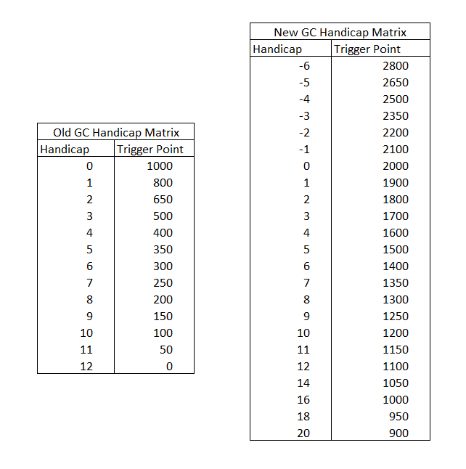

Notes:
- The steps from HC20 to HC6 are in steps of 50, 6 to -2 are in steps of 100 and beyond HC-2 steps of 150. In the old system there were steps of 50 up to HC4, 100 to HC3, 150 to HC1 then 200 to HC0.
- The most obvious change for the general playing population is that improving from HC6 to HC4 in the new system requires a player to gain 200 index points whereas in the old system it required 100.
- For most players the change is as simple as adding 1100 to the existing index.

