June 2018
News from the Board

Celebrate Our Croquet

You’re invited
Saturday 24 August 2019
Cheltenham Recreation Club
64-70 The Crescent
Cheltenham

10.00am tea and coffee on arrival
10.30am CNSW AGM
11.30am Break & visit Cheltenham Croquet facilities
12md-1.30pm – Lunch ($15pp) & Presentation of perpetual trophies
1.30pm – Launch of CNSW Strategic Plan 2019-2022 & member forum.

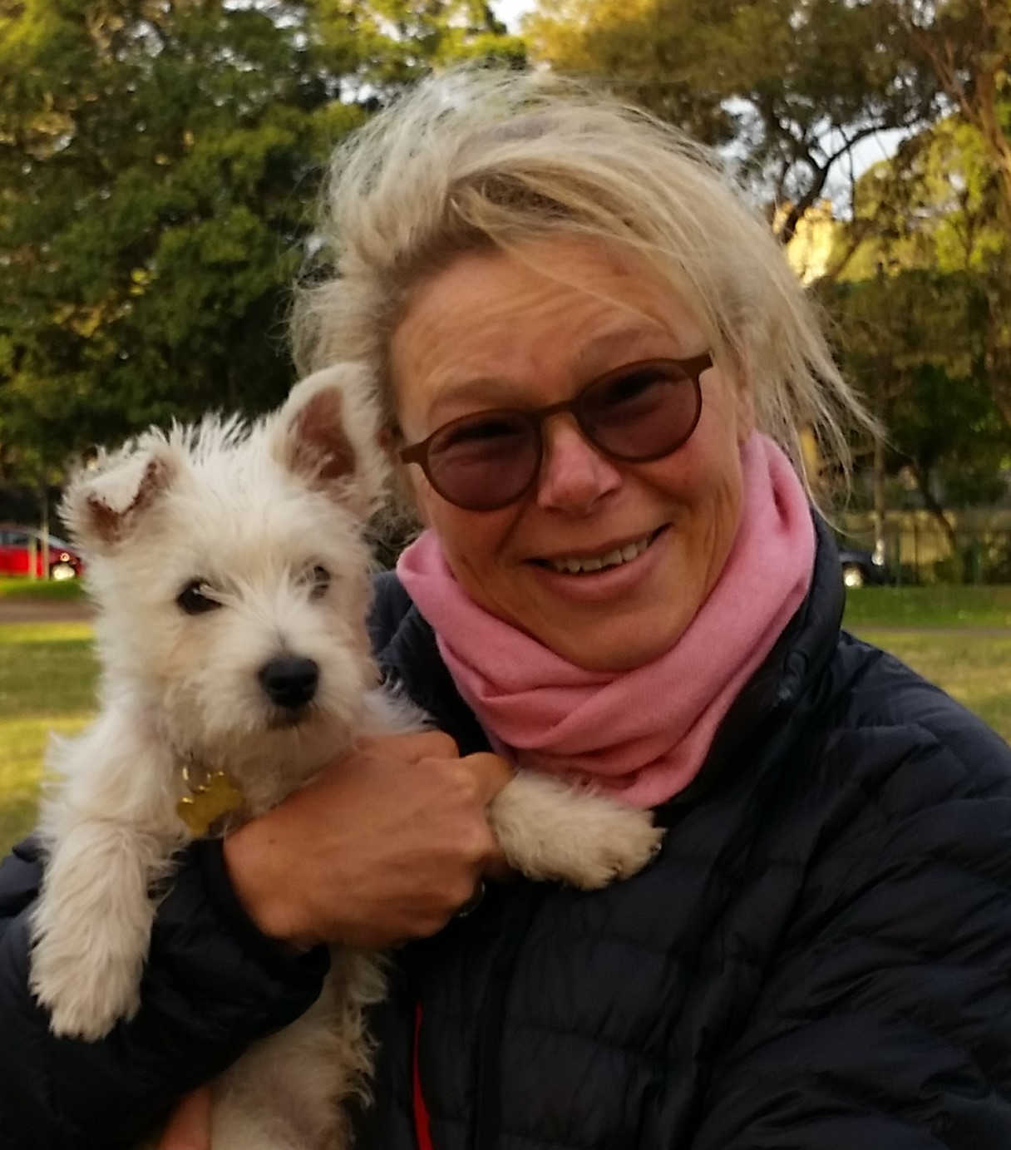

Player Pathways to Excellence Program

Many of you will have seen Alix Verge (and if you were lucky her pup Nigel) as she crossed the state delivering the Player Pathways to Excellence Program.

The Board has had a lot of positive feedback on the program thanks to the efforts of Alix & Pam Gentle and made possible by a grant to CNSW from the NSW Office of Sport.

Message from the Chair

I realise it is some time since my last message from the Board however there have been a lot of other communications to Clubs which show that things remain busy and productive across CNSW.

The Board has recently conducted a series of member information sessions about the revisions to the Constitution. Many of you may have had the chance to attend to understand the changes which, in short, aim to update the Constitution in line with the NSW Office for Sport Model rules, make provision for clubs that are not incorporated in their own right i.e. sub-Clubs of broader organizations such as a bowling club and to make the relationship of individual members to CNSW through their member club clearer. The Board hopes all clubs vote to support these changes.

The AGM is on August 24 and will be held at the Cheltenham Sport and Recreation Club, home to the Cheltenham Croquet Club. We have extended the day to include the annual presentation event (replacing the Christmas lunch) and a member forum to launch the CNW Strategic Plan 2019-2024. This is a day to celebrate Croquet and I encourage you to attend.

The awards event will also include the presentation of the inaugural Golden Mallet Award for outstanding contributions to Croquet. The award committee is calling for nominations for the award from CNSW members with a nomination form and the selection criteria to be circulated with this newsletter.

At the AGM four directors positions will be available for election as the last of the original Directors, Steve Thornton and John Eddes retire and two other directors, Tony McArthur and myself, have completed our current term, but are able to nominate for re-election. If you are interested in understanding the role of the directors and may have experience in management and/or organizational governance please contact me or one of the other Directors as we do need other members to support the governance of CNSW.

Brenda Wild

CNSW Chair on behalf of the Board

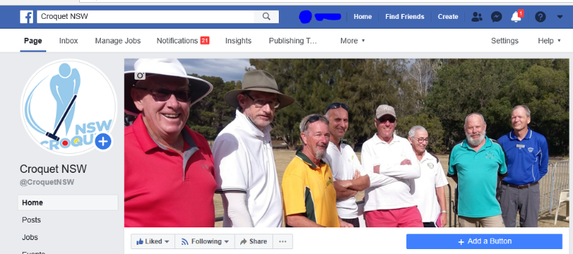

Keeping in touch in real time

Croquet folks across NSW and the ACT can keep in touch through our Facebook pages.

Social media like Facebook is a way of promoting Croquet in the local community as well as making connections with members of clubs across NSW and into the broader universe of Croquet. If you are a follower of our Facebook page and group over the last few months you will have seen a lot – from Channel 7’s Sunrise at Mosman Croquet Club – great coverage – thanks Mosman! And kept abreast of the excitement of Jamie Gumbrell (Canberra Croquet Club) and Charlie Sharpe (Killara) preparing for the U21 GC World Championships in the UK. There are a number of clubs like Urunga, Mount Sugarloaf and South West Rocks that have newly created Facebook pages as notice boards to their membership, with Coutts Crossing, Lithgow, Marrickville and Queanbeyan with long standing pages. While there people who don’t currently use Facebook why not have a test run so you too can enjoy this connection across the world of croquet. If you are uncertain as to how to do this or need help (particularly to ensure privacy settings are in place)just ask someone at your club who has an account for some help (or a grandchild)!
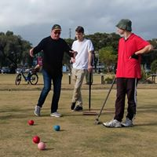
May all your roquets run straight!
Jamie Gumbrell (Canberra/ above right) and Charlie Sharpe (Killara/centre) are off to compete in U21 GC World Championships at the Nottingham Croquet Club in England from
Saturday, 20 July.

July events still open for entry
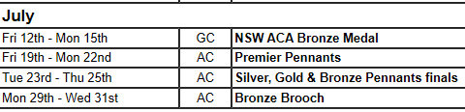

Where’s the newsletter?

We are still considering options around the CNSW Newsletter. Hopefully you all saw the call for a volunteer or group of volunteers who are willing to take on a role in producing a regular newsletter.

While social media is great in real time (read below) it is also good to have something to pass around between members to discuss. We do want to continue to cover all options and if you can assist please email the secretary@croquet-nsw.org.

Sports Development Officer

Donna Olbourne, our Development Officer, is working hard behind the scenes talking to Clubs about how her role can best support them.

Donna did a recent survey of Clubs and we hope you all had the opportunity to assist in the development of this feedback.

Donna’s work is been made possible through a grant from the NSW Office for Sport.

