REPLACING BALLS AFTER COLLISIONS
In a double-banked game, a ball from one game (the striker’s ball) may collide with a ball from the other game (the other ball). The other ball has to replaced in its original position, while the position of the striker’s ball is estimated from the distances travelled by it and the other ball.
A ramp was set up and balls were run down it, first to see where the ball would finish up without a collision, then placing a ball in its path to see where each ball went after the collision.
The following were the results:
NO COLLISION DIST. STRIKERS BALL DIST OTHER BALL DIST. RATIO*
7.15 m 2.40 1.82 2.61
7.15 0.63 2.50 2.61
4.65 0.9 1.55 2.42
4.65 1.55 1.23 2.52
4.65 0.39 1.58 2.69
5.90 2.76 1.24 2.53
* The ratio is the value of a in the equation d = a.x + y where d = distance travelled without a collision; x is the distance travelled by stationary ball; and y is the distance travelled by the moving ball.
Thus, the figure of 2.5 times the distance travelled by the stationary ball, plus the distance of the moving ball, is a reasonable estimate of the correct placement of the moving ball.
It is interesting that hitting the other ball head-on and hitting it at an angle made little difference to the ratio.

strikers ball after collision

position
collision point with no collision
other ball after collision

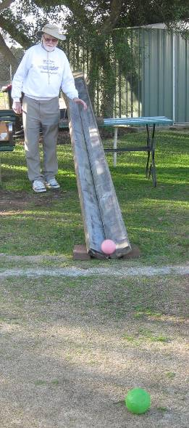
Photo of test arrangement

